Michael Beebe

Dr. Jennifer Crissman

ITCS 1880

September 14, 2020

**Lab Assignment 4**

1. Built-In R Data

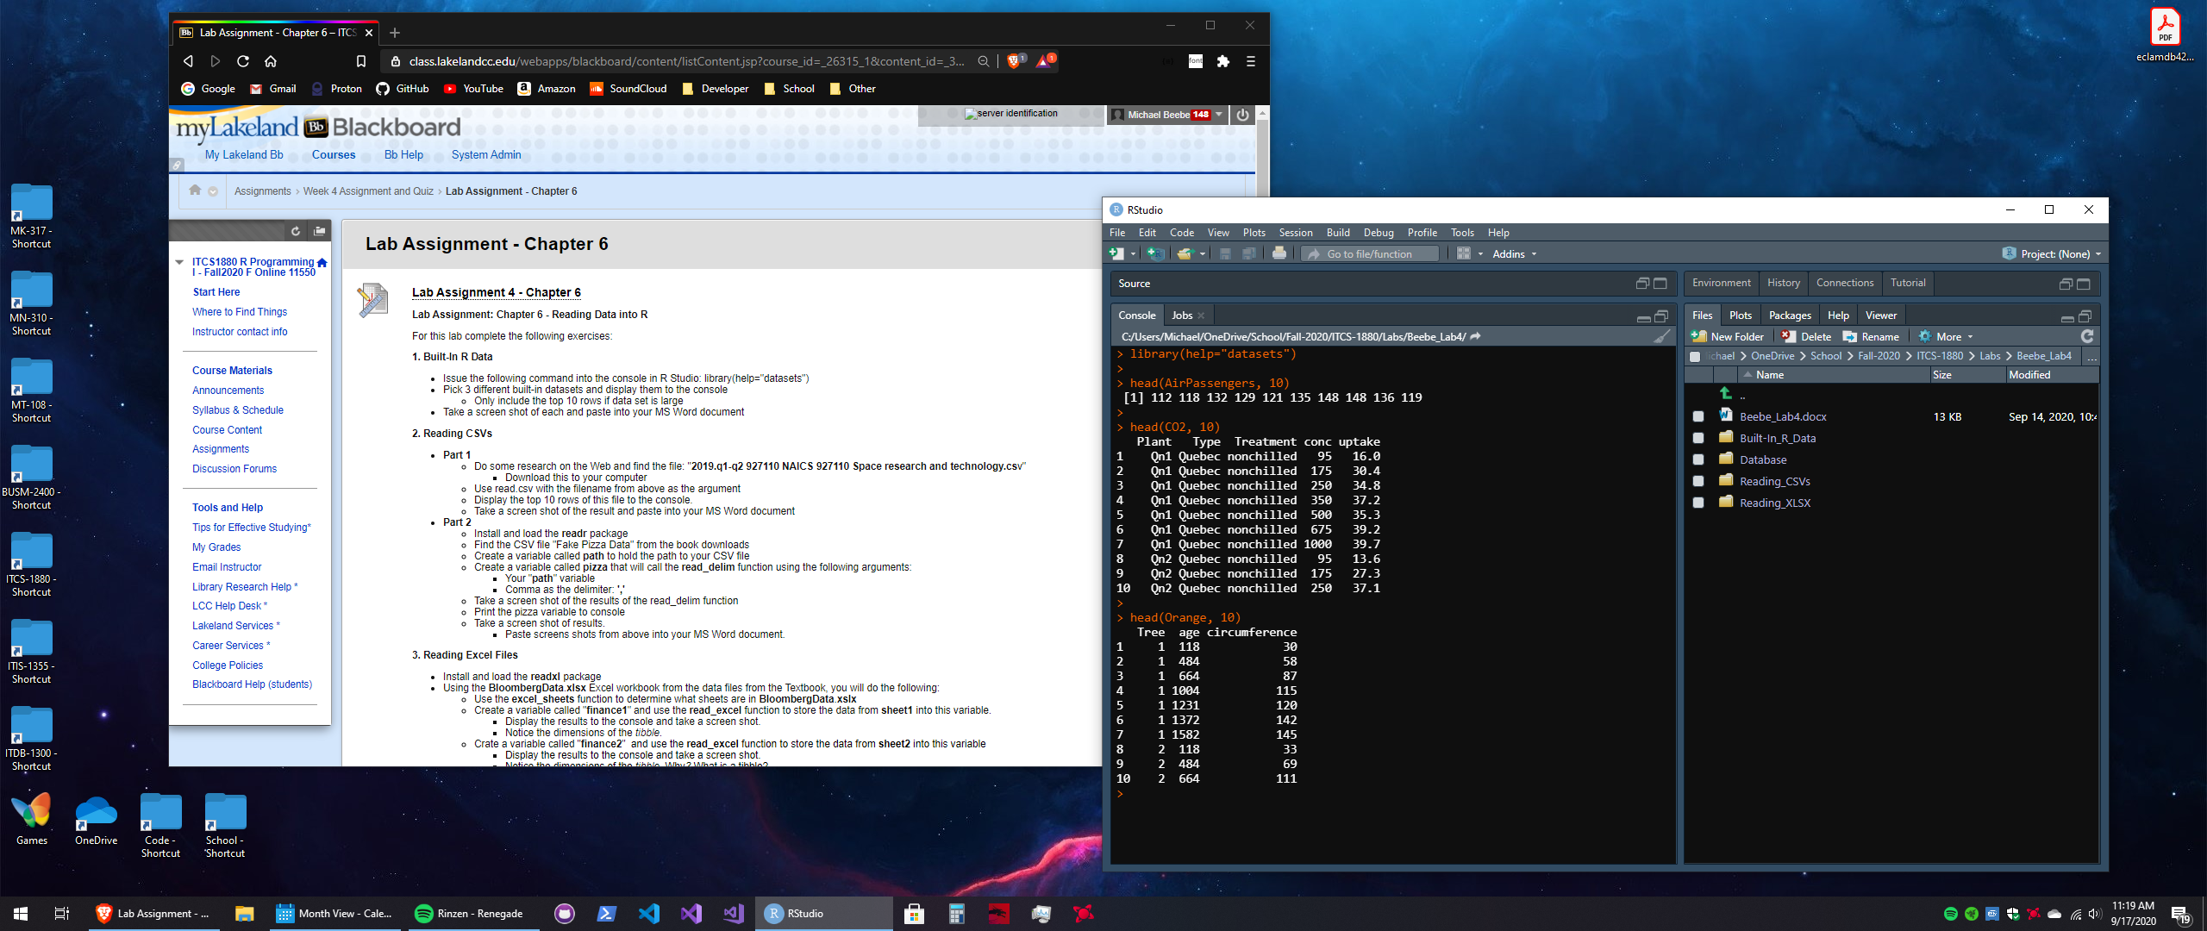

2. Reading CSVs

Part 1

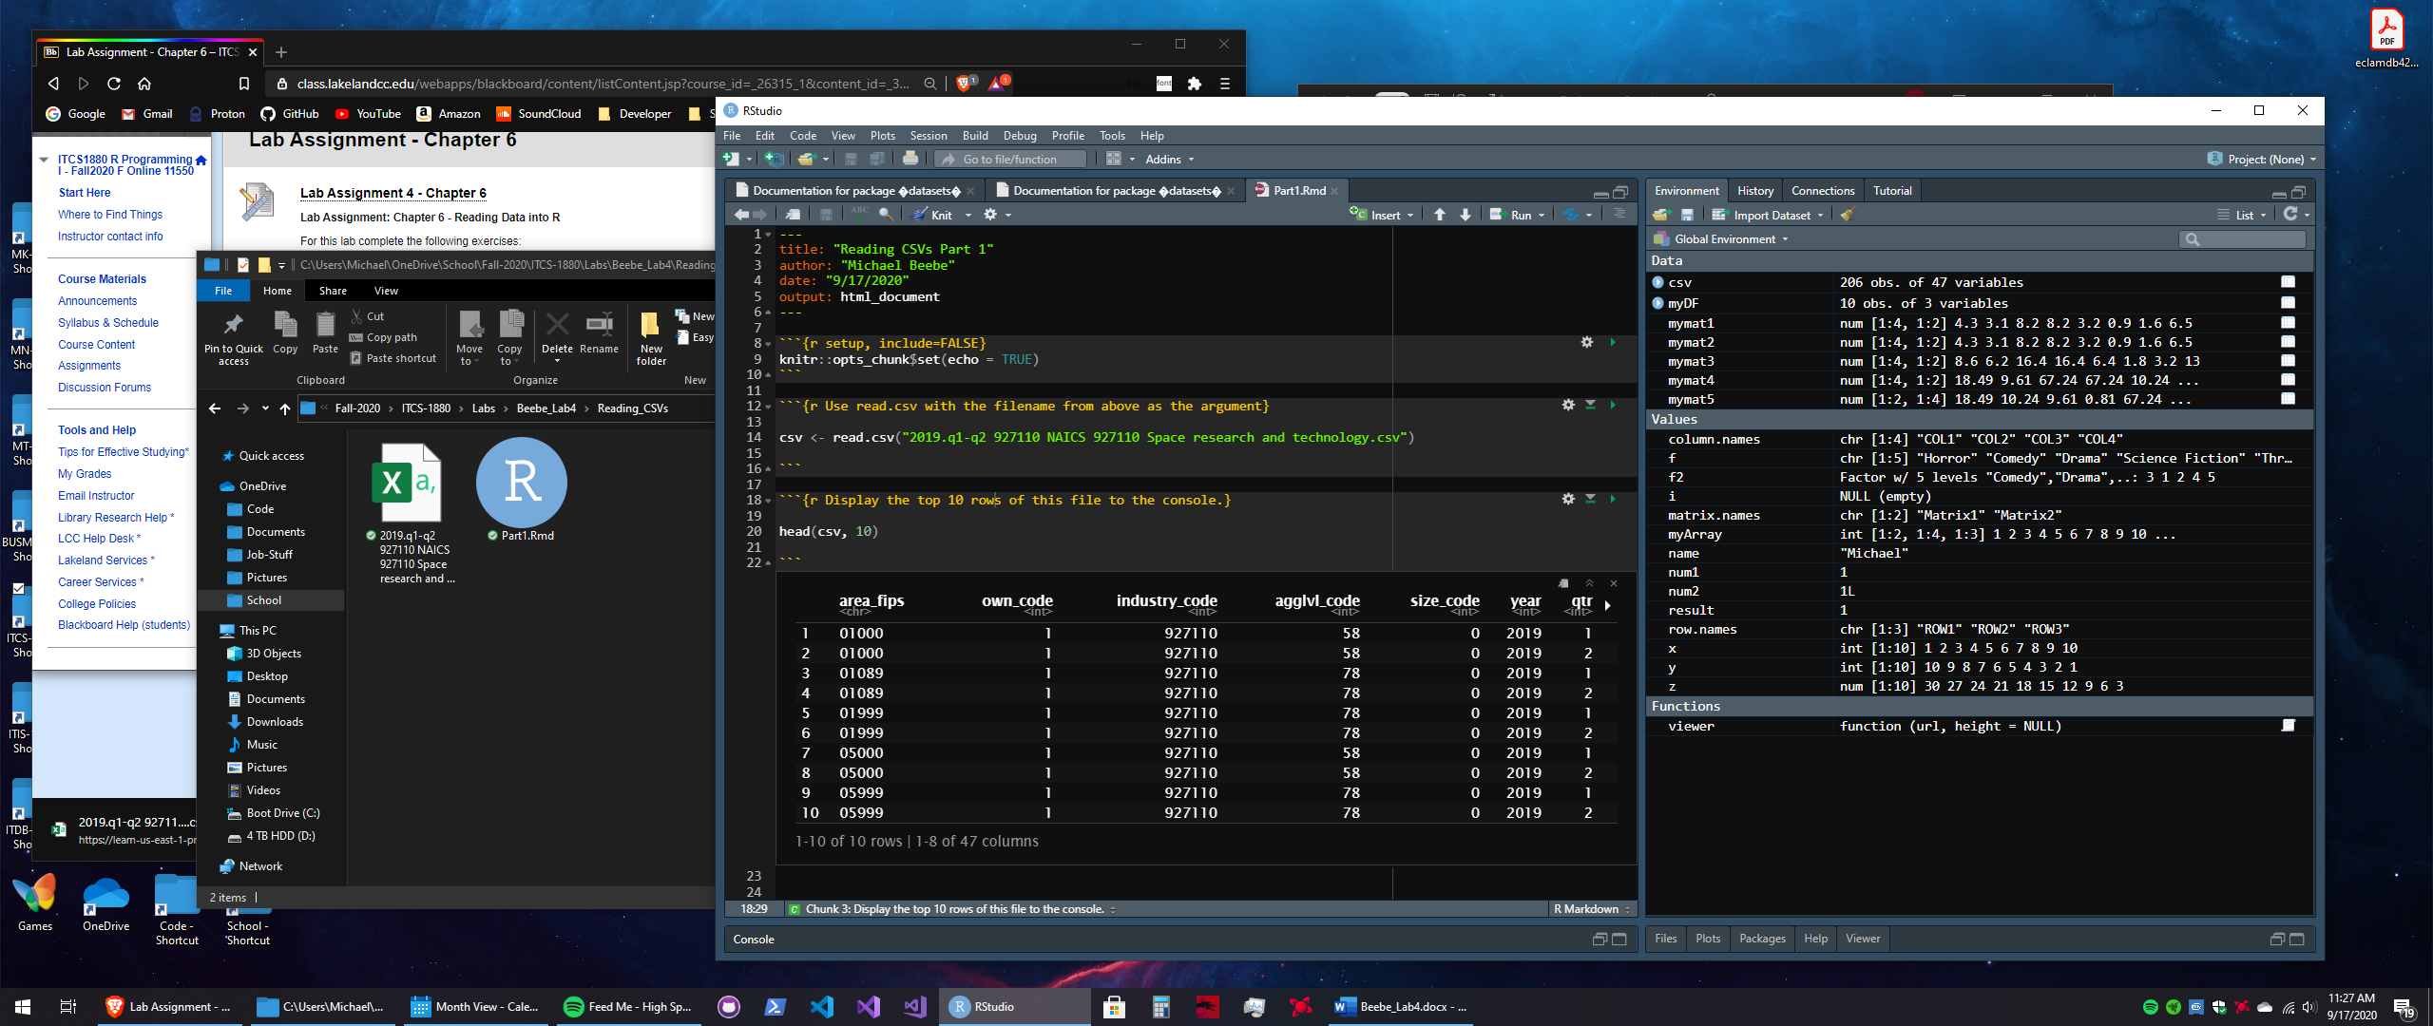

Part 2

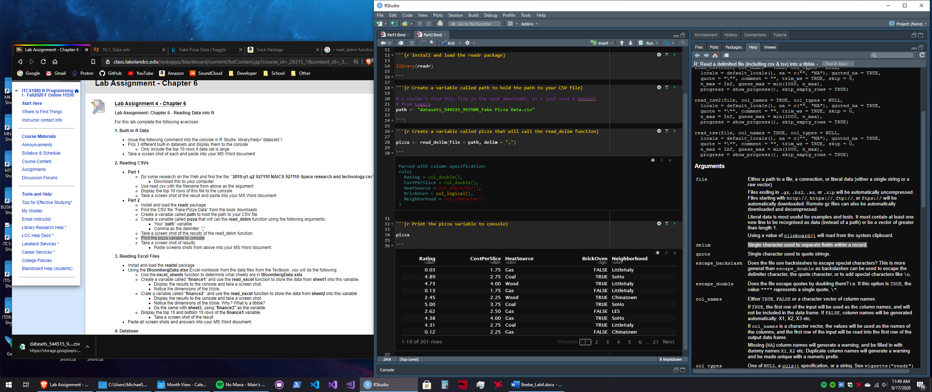

3. Reading Excel Files

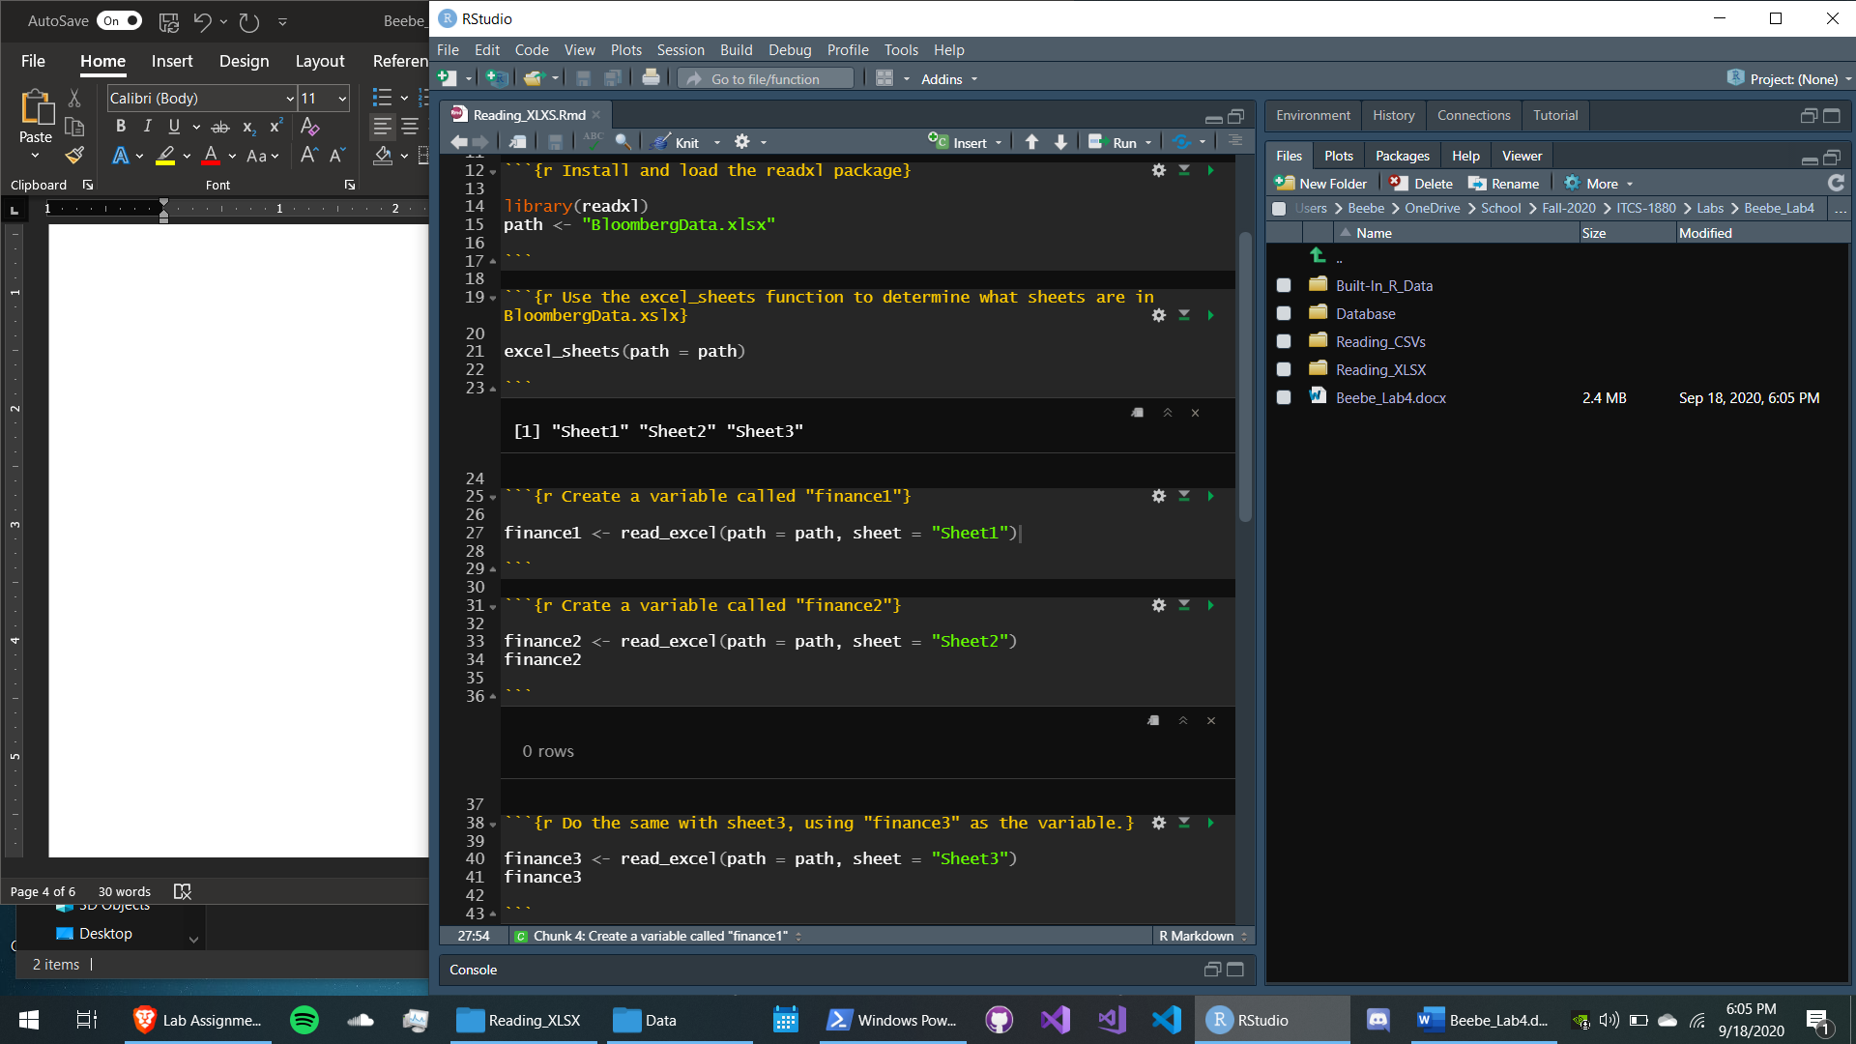

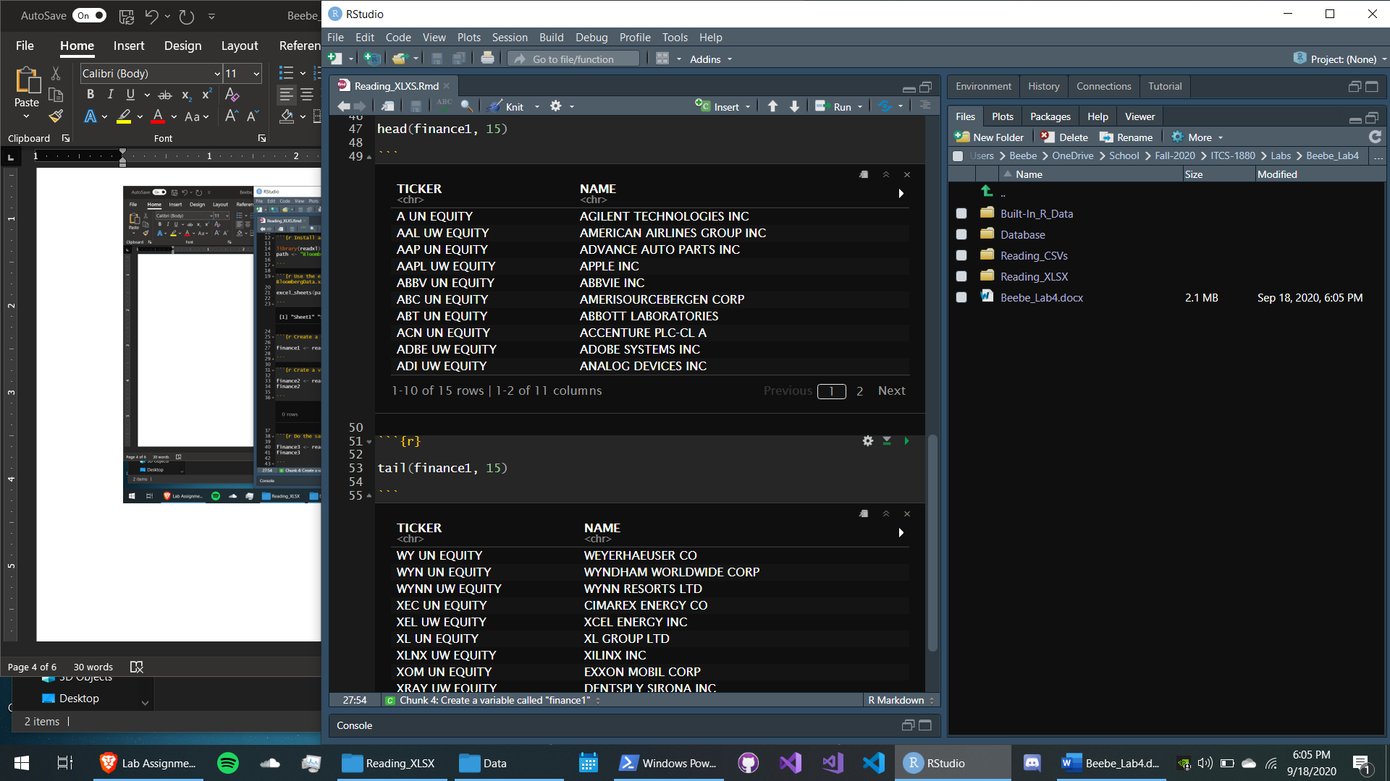

4. Database

